|  |
| --- |
| Microsoft Fabric for Analytics  PT Mitra Integrasi Informatika |

Table of Contents

1. Introduction 2

2. Prerequisite 2

3. Fabric Lab Setup 3

1.1. Fabric License 3

1.2. Resource Setup 4

1.1.1. Fabric Workspace 4

1.1.2. Lakehouse 6

4. Get Data 8

1.3. Get Dimensional Data from Excel 8

1.4. Get Fact Data from Flat File (CSV) 16

1.5. Automate the data ingestion using data pipeline 21

5. Create Report 25

1.6. Create report from lakehouse data 25

6. Clean Up Resources 43

# Introduction

This training serves as introduction to end to end analytics in Microsoft Fabric.

Participants will work on ingesting data, transforming them, analyze them as a model. For data ingestion, in this training we will work on multiple csv files for sales data and an excel for dimensional data. Participants will ingest the data using Dataflow and Notebook. The ingested data will be stored in lakehouse. Then using data ingested on Power BI and create a simple report on sales data.

For this training participants will use sales data of 3 sample country (USA, Japan, Australia). Those data will then be combined with date, geography, products, and manufacturer as supporting dimensions.

Participants will work with basic objects and features on analytics in Microsoft Fabric like:

* Data Factory Features
  + Dataflow gen2
  + Data pipeline
* Data Engineering Features
  + Lakehouse
  + Notebook
* Power BI Features
  + Power BI Report

# Prerequisite

Each user must have all items prepared before the lab:

1. Web Browser to access Power BI Service on <https://app.powerbi.com/> .

Google Chrome is recommended.

1. Each user has Power BI license with fabric trial activated or available for upgrade (lab setup will cover for this scenario), user that has previously upgrade to trial with expired license will need to get new user login.

# Fabric Lab Setup

## Fabric License

1. Open the **browser** and navigate to https://app.powerbi.com/. You will be navigated to the login page.
2. Enter your **Email** account and click **Submit.**   
   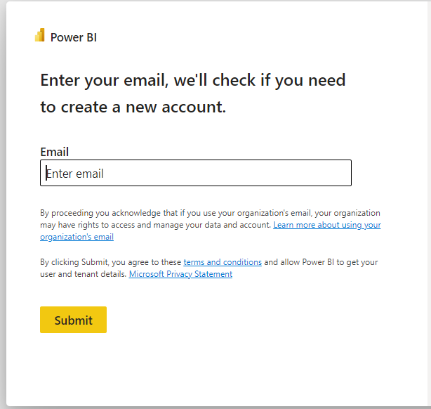
3. You will be navigated to the **Password** screen or company sign in page. Enter your password.
4. Click **Sign in** and follow the prompts to sign into Fabric.
5. You will be navigated to the familiar **Power BI Service Home page**.
6. On the top right corner of the screen, select the **user icon**.
7. Select **Start trial**.  
   
8. Upgrade to a free Microsoft Fabric trial dialog opens. Select **Start trial**.  
   
9. Successfully upgraded to a free Microsoft Fabric trial dialog opens. Select **Fabric Home Page**.  
   
10. You will be navigated to the **Microsoft Fabric Home page**.  
    

## Resource Setup

### Fabric Workspace

1. Now let’s create a workspace with Fabric license. Select **Workspaces** from the left navigation bar. A dialog opens.
2. Select **New workspace**.  
   
3. **Create a workspace** dialog opens on the right side of the browser.
4. In the **Name** field enter **FABRIC_<username>**
5. If you choose, you can enter a **Description** for the workspace. This is an optional field.
6. Click on **Advanced** to expand the section.   
   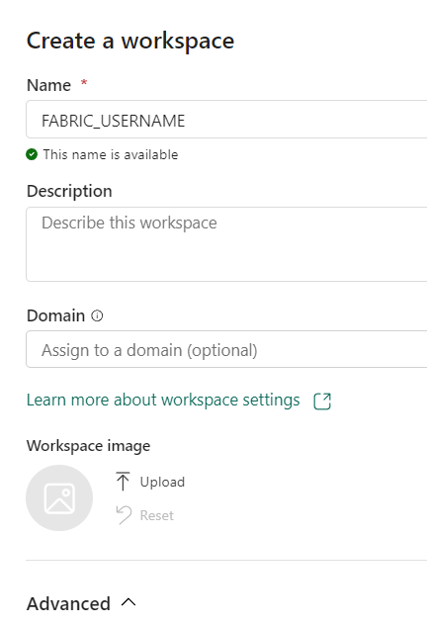
7. Under **License mode**, make sure **Trial** is selected. (It should be selected by default.)
8. Select **Apply** to create a new workspace.  
   

### Lakehouse

1. Select **Data Engineering** to be navigated to Data Engineering Home page.  
   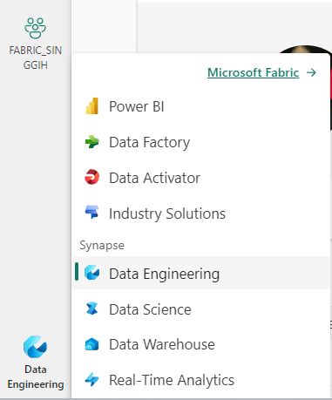
2. Select **Lakehouse**. 
3. New lakehouse dialog opens. Type **lh_fabric** in the Name textbox.
4. Select **Create**.  
   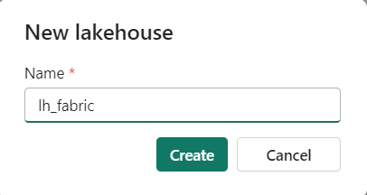

# Get Data

## Get Dimensional Data from Excel

1. On the main page of the lakehouse, choose get data option and select New Dataflow Gen2  
   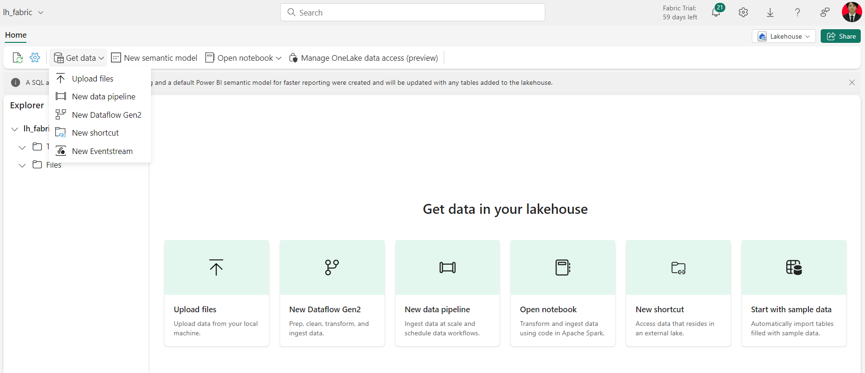
2. Change the created dataflow name by clicking on the dataflow default name on the top left.  
   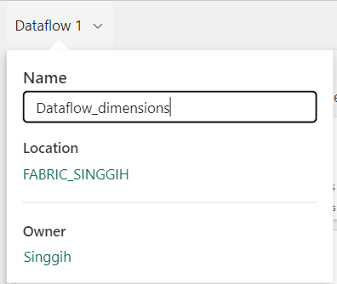
3. Next choose Get Data and pick Excel Workbook as the new source  
   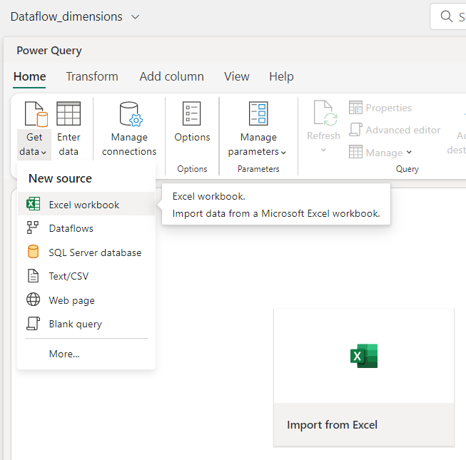
4. Select **Link to file** and under the **File path or URL** enter this link <https://raw.githubusercontent.com/Singgoli/FabricTrainingResource/main/Data/DIM.xlsx>
5. Under **Connection** choose Create new connection, under **Authentication kind** choose Anonymous.  
   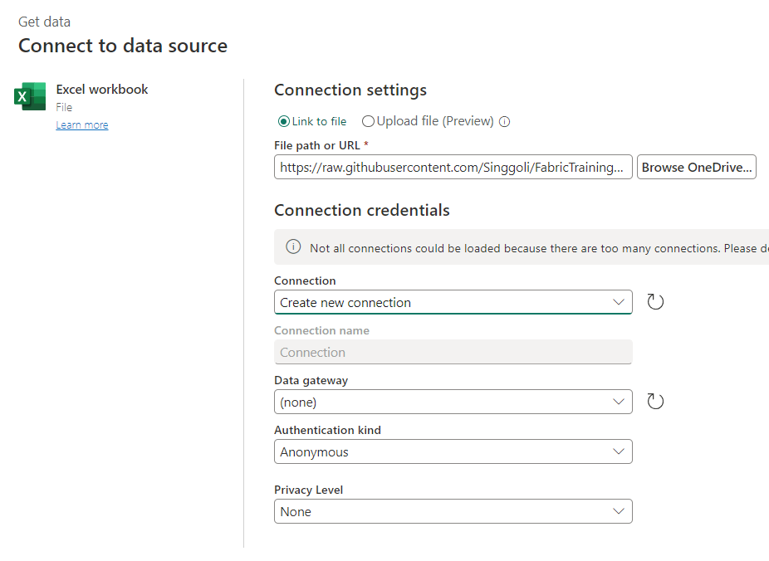
6. On the **Choose Data** window, any sheets or tables in the excel will be listed. For this exercise, tick the 4 worksheets below.  
   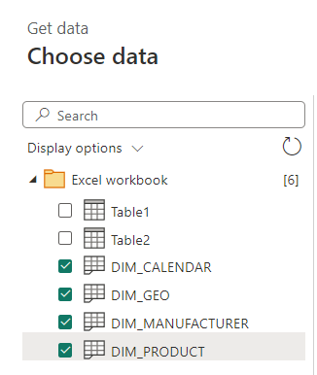
7. Then click **Create**.
8. This will result in 4 queries created for each worksheets  
   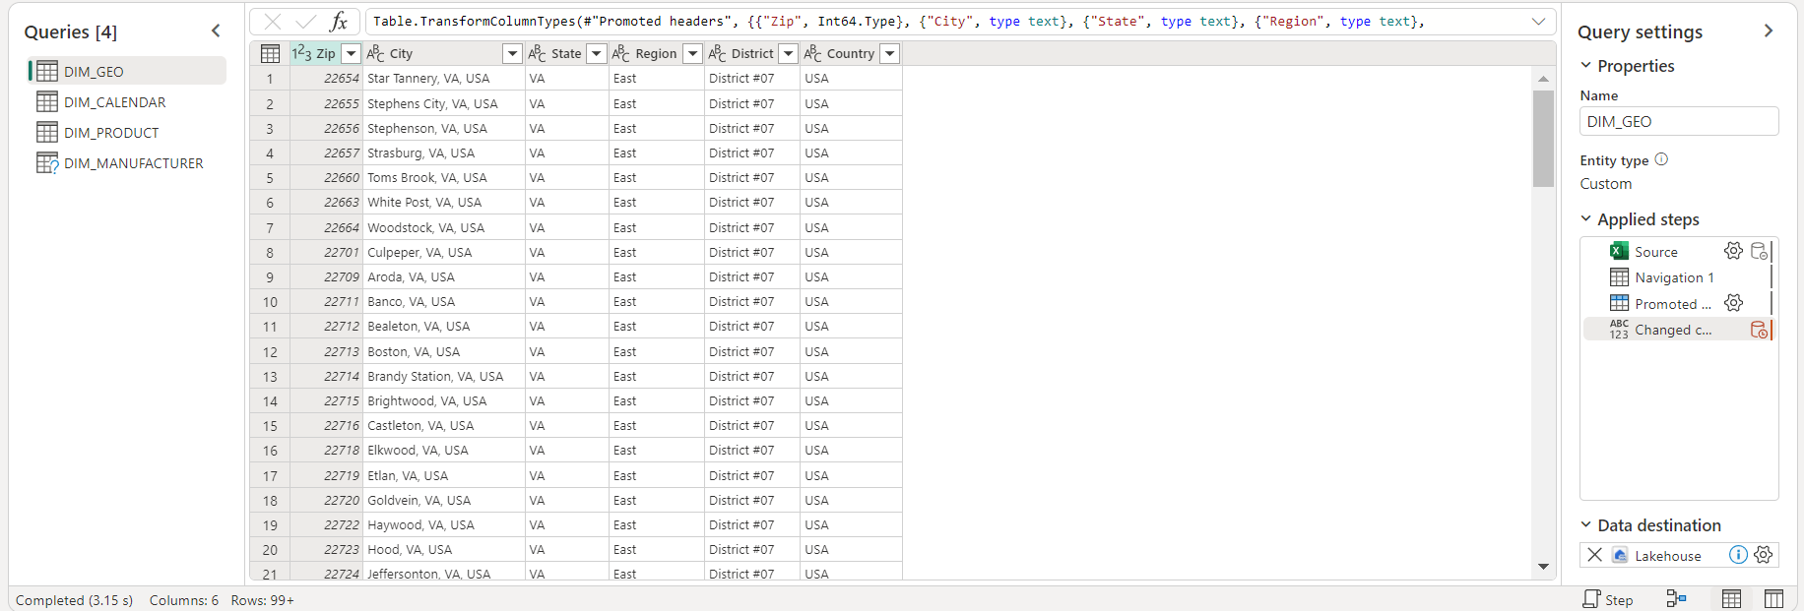
9. Select the query for DIM_GEO, Change the data type for **Zip** column to Text by clicking the 123 symbol  
   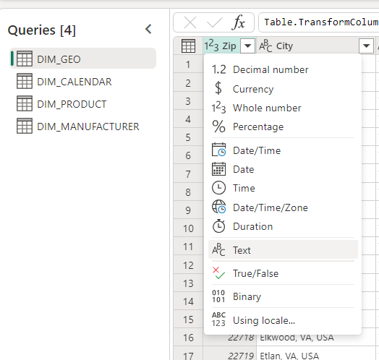
10. Choose Replace Current when prompted to replace the suggested automatic data type conversion.  
    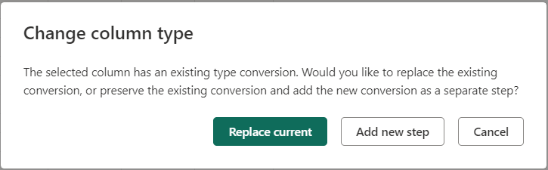
11. Next go to **DIM_PRODUCT** query and select the **Price** column. On the **Transform** toolbar, select Split Column and choose by positions.  
    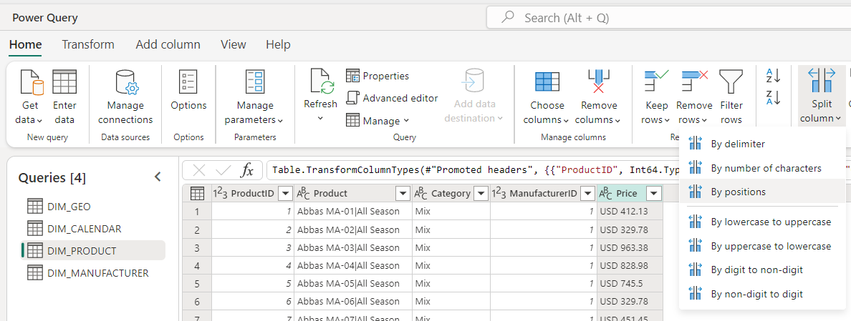
12. Under the **Positions** enter 0, 4 to split the data into 2 column by 1st character and 5th character.  
    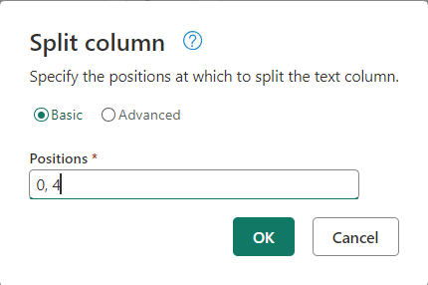
13. It will split the data to currency and amount columns  
    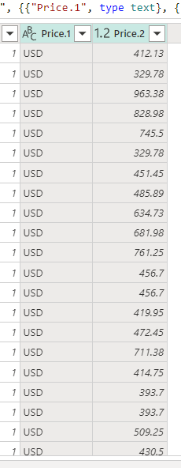
14. Rename the 2 result columns as **Currency** and **MSRP** by choosing **Rename** in dropdown menu after right clicking the column name or double clicking the column name.  
    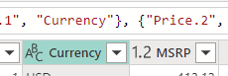
15. Go back to DIM_GEO and select **Zip** and **Country** columns by holding **CTRL** when clicking the 2 columns. Then go to **Add column** toolbar and select **Column from examples>From selection**.  
    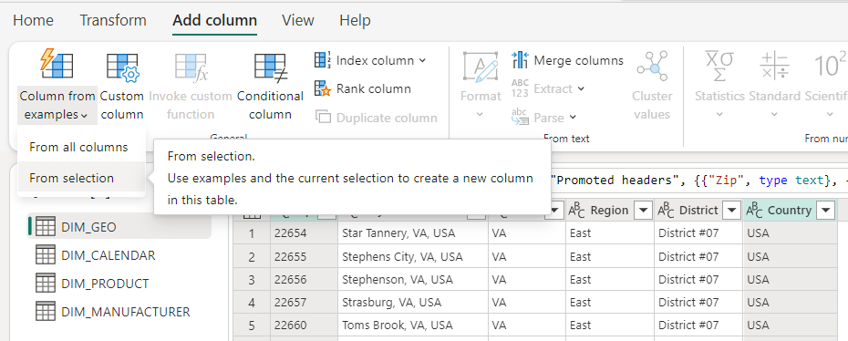
16. Input the value in **Zip** followed by “ – “ and then value from **Country** in the first row. It will then automatically generate the equivalent script from the example. Select **OK** if the sample shows the desired results.  
    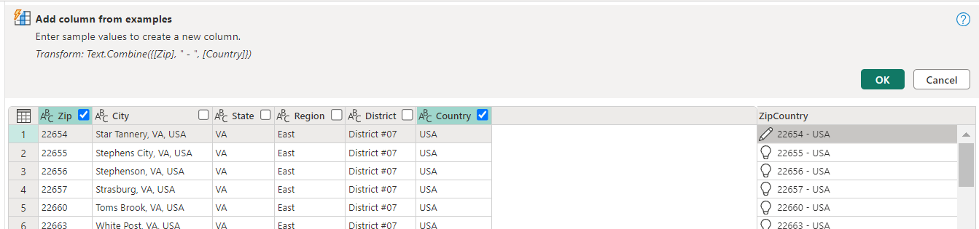
17. Next select **DIM_CALENDAR** and column **date_full**, on the **Add column** toolbar choose the **Date > Year > Year** option. This will add a new column consisting of the year value of the date.  
    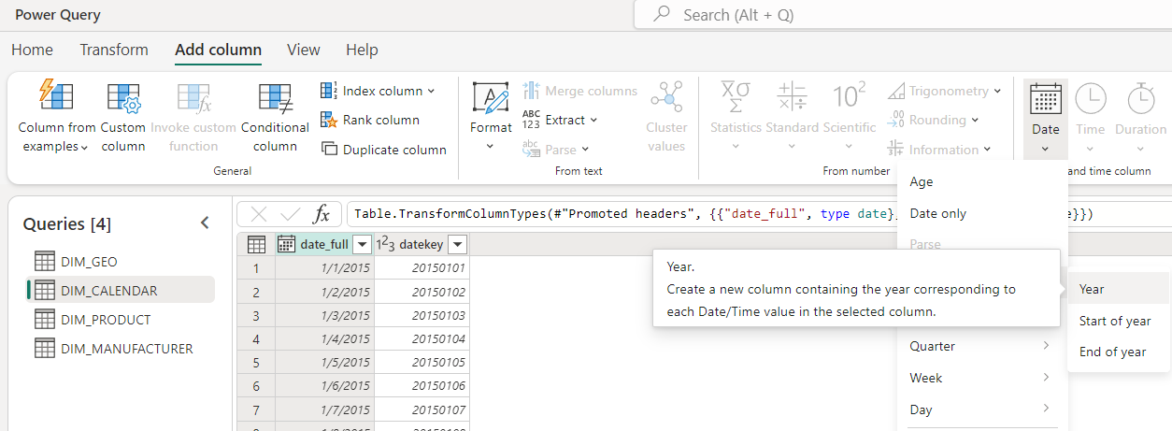
18. Repeat the process to add Month, Name of month and Day. Also change the data type of **Year**, **Month** and **Day** to whole number.  
    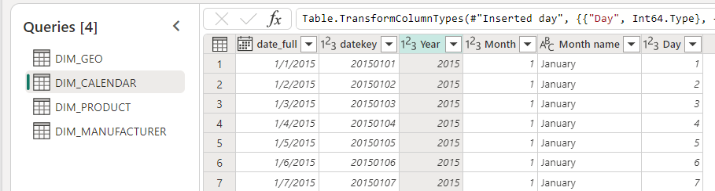
19. Select any query and check on the bottom right for **Data destination** option. Click on the cros to add data destination and select **Lakehouse**.  
    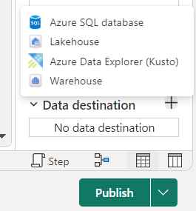
20. Choose to **Create a new connection** and set **Authentication kind** to **Organizational account**.  
    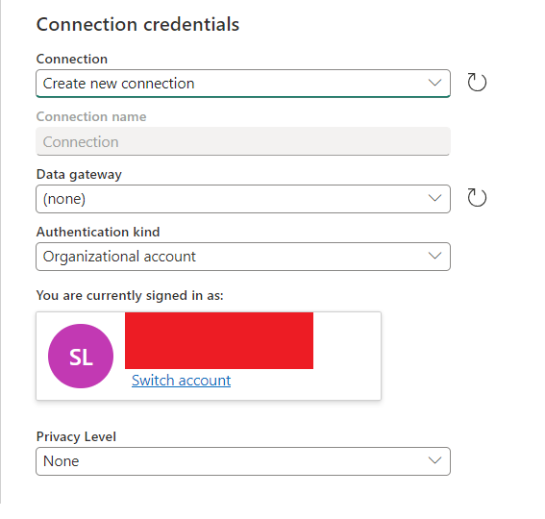
21. Next select the workspace and lakehouse created earlier during the lab and select **New table** instead of existing. Change the table name as needed then click **Next**.  
    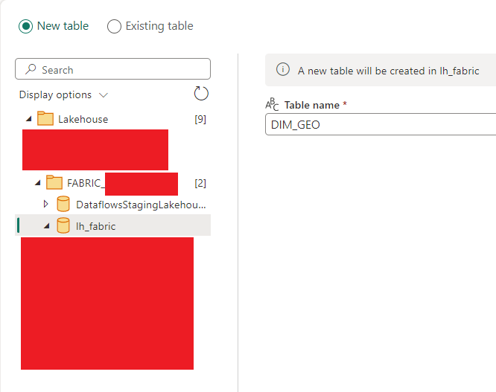
22. Disable the **Use automatic settings** option and select **Replace** as **Update method** also select **Fixed schema** for **Schema options on publish**. Click **Save settings**.  
    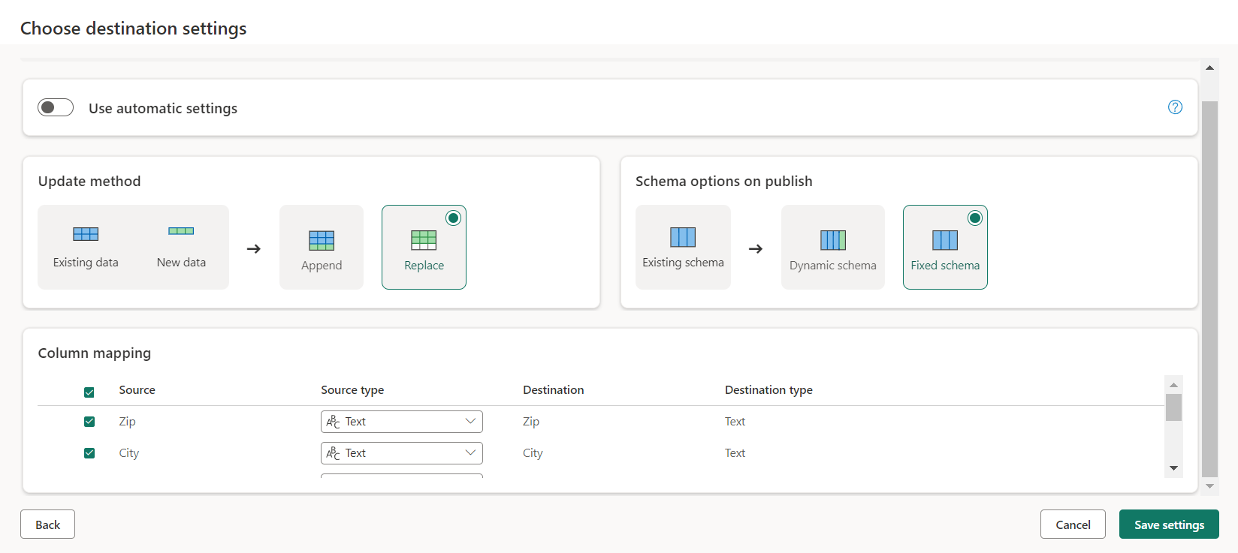
23. Repeat the process to add destination for the other 3 queries.
24. Once finished publish the dataflow using Publish button on bottom right.  
    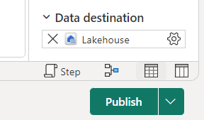

## Get Fact Data from Flat File (CSV)

1. Open your lakehouse, from the ribbon on top choose Open notebook and choose New notebook.  
   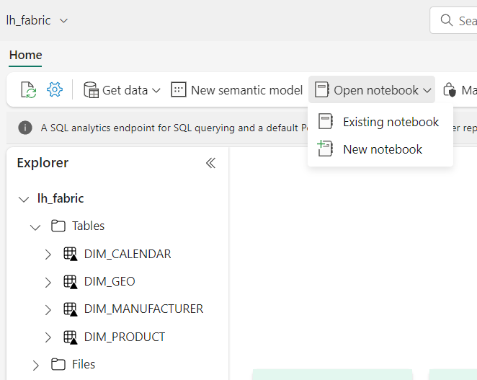
2. Once opened change the value text the existing cell and change the cell into a **Markdown cell.**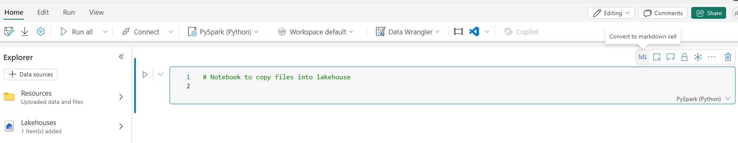
3. After that create a new Code cell by selecting **+ Code** below the existing cell.  
   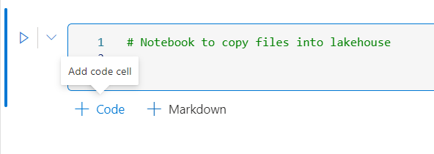
4. Copy the following code into the code cell

|  |
| --- |
| import pandas as pd  df = pd.read_csv("https://raw.githubusercontent.com/Singgoli/FabricTrainingResource/main/Data/Sales/USA.csv")  df2 = pd.read_csv("https://raw.githubusercontent.com/Singgoli/FabricTrainingResource/main/Data/Sales/Japan.csv")  df3 = pd.read_csv("https://raw.githubusercontent.com/Singgoli/FabricTrainingResource/main/Data/Sales/Australia.csv")  def clean_data(df):      # Created column 'Country' from formula      df['Country'] = "USA"      return df  df_clean = clean_data(df.copy())  df_sales = pd.concat([df_clean,df2,df3],axis = 0)  df_sales.to_csv("[PATH HERE]/salesdata.csv") |

1. On the explorer tab to the left select your lakehouse and find the Files folder. Click the ellipsis to the right of it and choose **Copy ABFS path.**  
   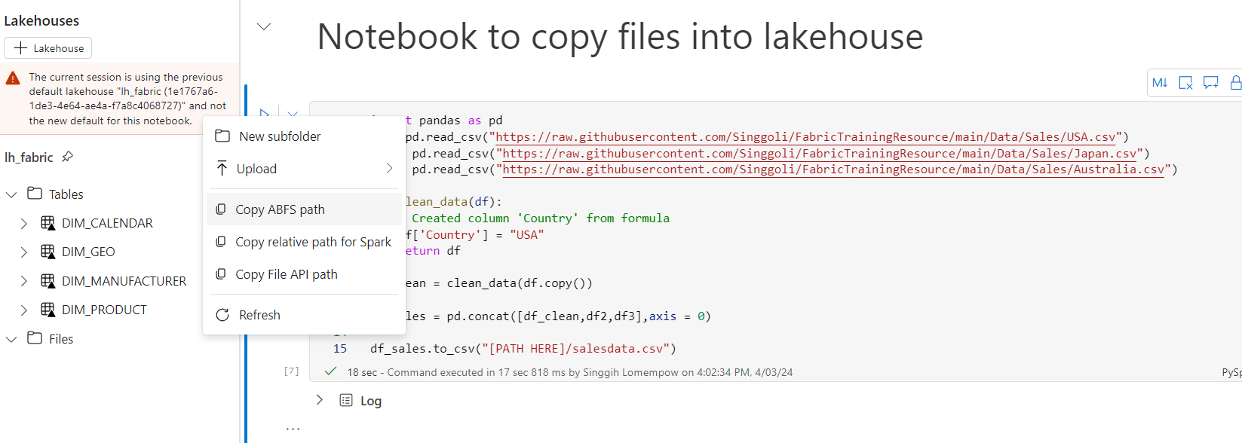
2. Replace the **[PATH HERE]** segment on the code with the ABFS path copied. It will look like this  
   
3. Next run the notebook using **Run all** option  
   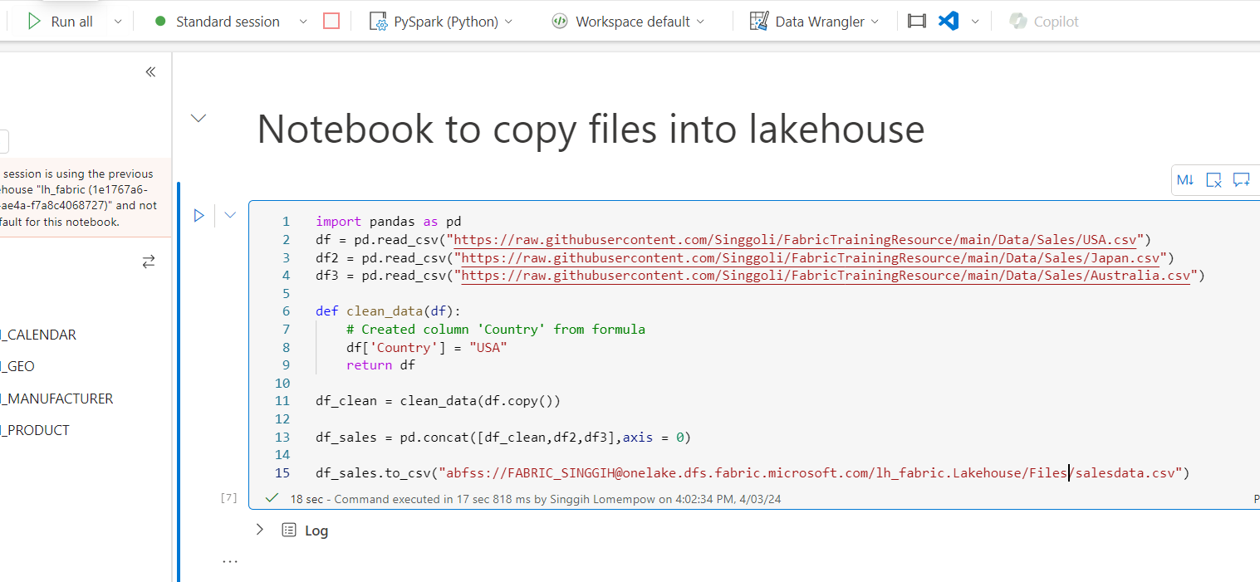
4. Once finished refresh the Files folder and click it, it will show the file salesdata.csv  
   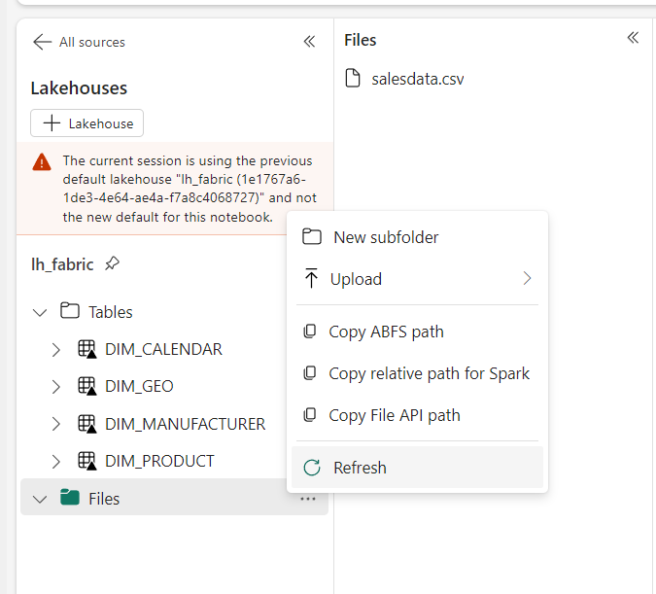
5. Add a new code cell and copy this command there and then run the code cell.

|  |
| --- |
| import pandas as pd  # Load data into pandas DataFrame from "/lakehouse/default/" + "Files/salesdata.csv"  df4 = pd.read_csv("/lakehouse/default/" + "Files/salesdata.csv")  def clean_data(df4):      df4 = df4.drop(columns=['Unnamed: 0'])      df4['Date'] = pd.to_datetime(df4['Date'])      df4['Zip'] = df4['Zip'].astype(str)      df4['ZipCountry'] = df4.apply(lambda x : x['Zip'] + ' - ' + x['Country'], axis = 1)      return df4  df5 = clean_data(df4.copy())  dfspark = spark.createDataFrame(df5)  dfspark.write.format("delta").mode("overwrite").saveAsTable("FACT_SALES") |

1. Once the cell finished running refresh the Tables folder. There will be a new table named fact_sales. To preview the data load it to spark and run the created code cell.  
   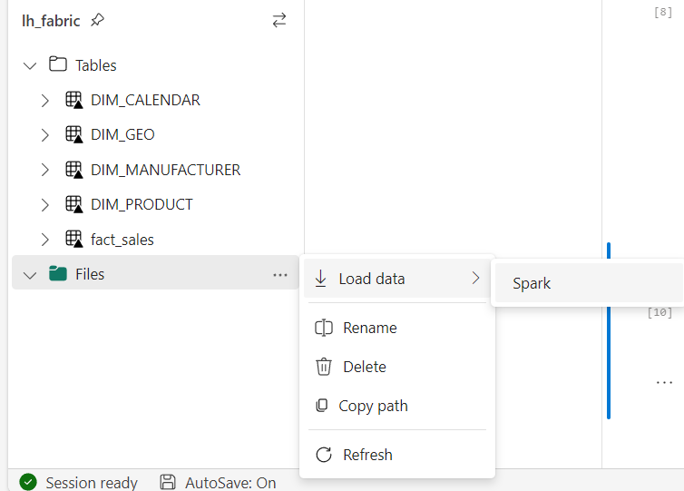
2. Finally rename the notebook from the top left menu. And stop the spark session using the red rectangular button.  
   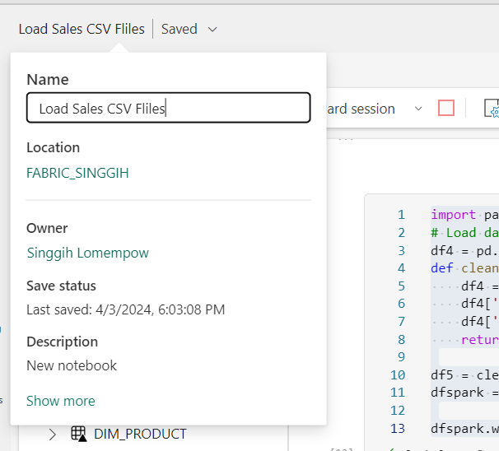

## Automate the data ingestion using data pipeline

1. Go back to your created fabric workspace, click on the create new Data pipeline.  
   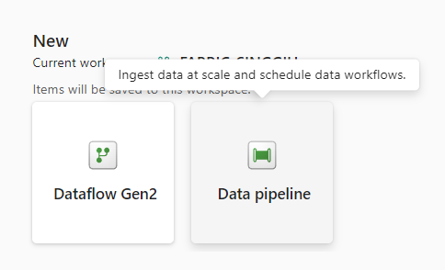
2. You will be prompted to name the pipeline, name it **pipeline_fact**.
3. Choose to start with a blank canvas and a pipeline activity, then on the selection choose Transform>Notebook.  
   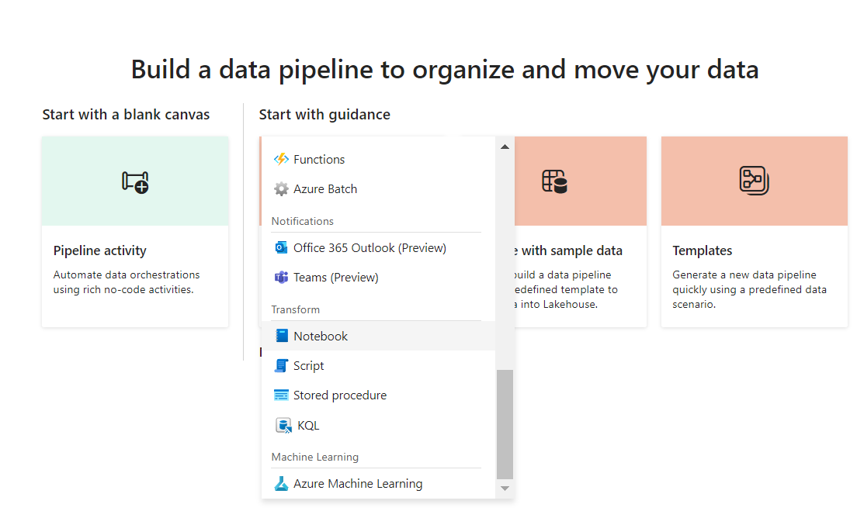
4. Rename the pipeline object into **Load Sales Notebook** on the General tab.  
   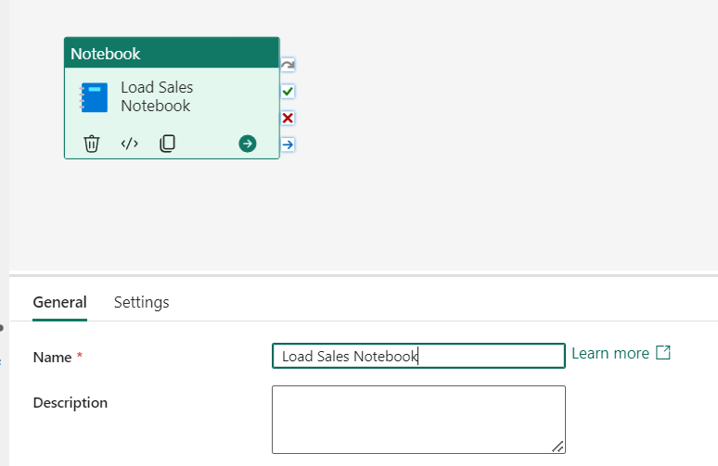
5. Next, go to the Settings tab and select the **Load Sales CSV Files** notebook.  
   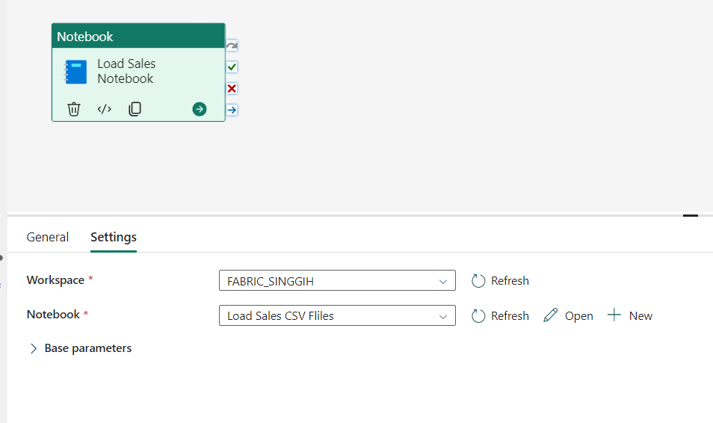
6. Test run the pipeline using the run button.  
   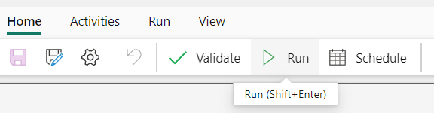
7. Wait until the run completed, you can see the execution result in the bottom pane  
   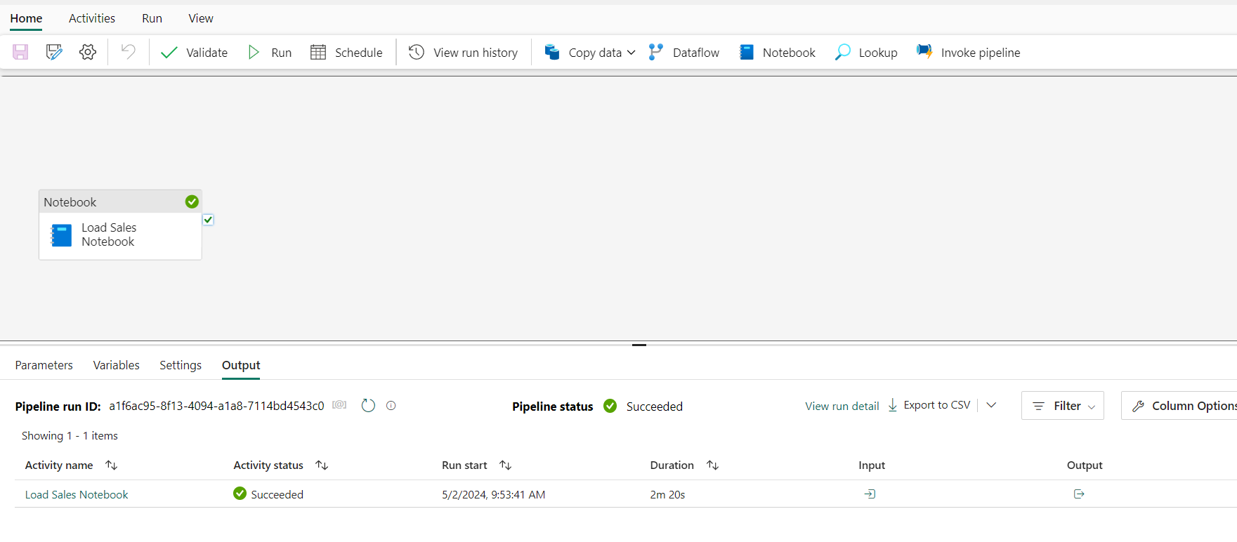
8. To create a scheduled automation, click the schedule button.  
   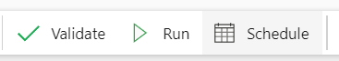
9. Configure the schedule as required, for this example the run is scheduled daily on 12.00 AM for 2 days. Once finished click Apply.  
   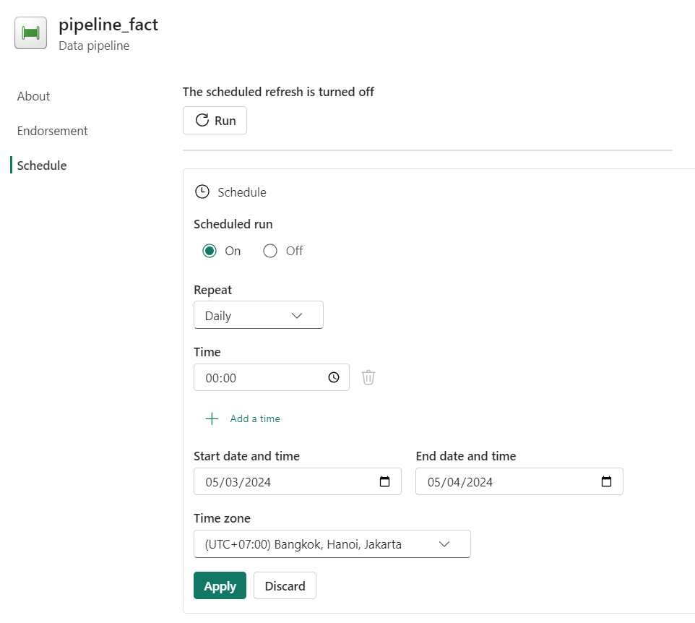
10. Once finished you can see the next run schedule above.  
    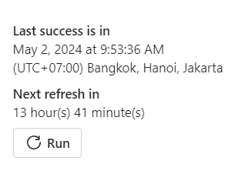
11. Save your pipeline using the save button.  
    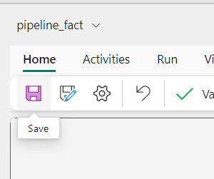
12. Once the save is completed, you can close the notebook and go back to fabric workspace.  
    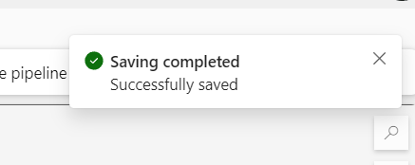

# Create Report

## Create report from lakehouse data

1. Access your lh_fabric lakehouse using **SQL analytics endpoint**.  
   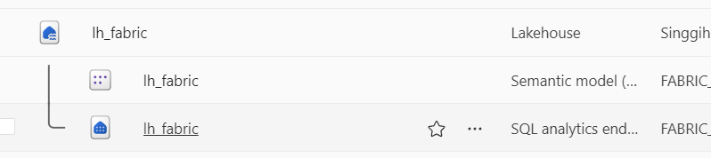
2. Once opened go to **Reporting** tab and click **New semantic model**.  
   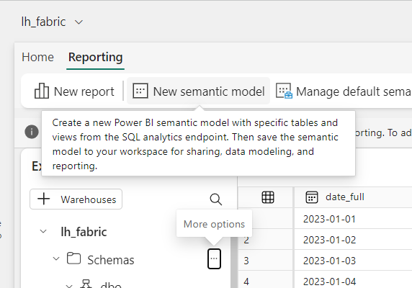
3. Name the semantic model **pbi_fabric_<your name>** and select all table we have created until now. Review your input and selection then click **Confirm**.  
   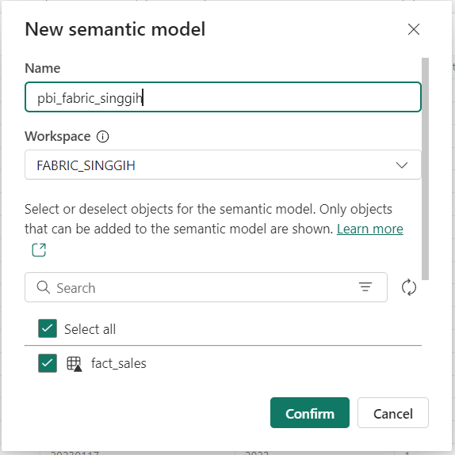
4. Go back to your fabric workspace and confirm the semantic model is created. Open the semantic model by clicking it.  
   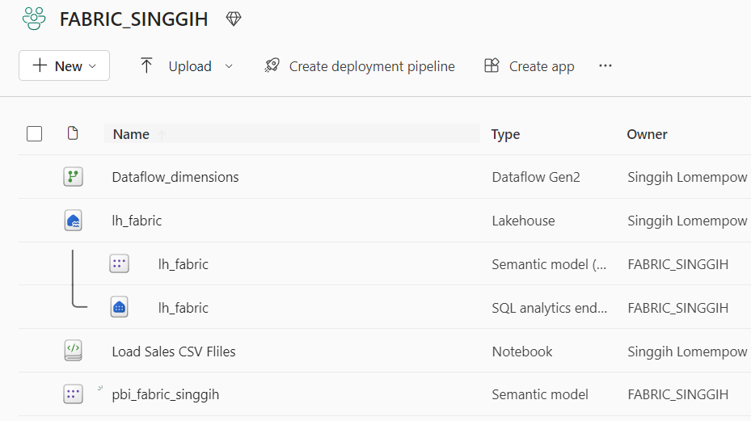
5. Once opened, click Open data model on the menu  
   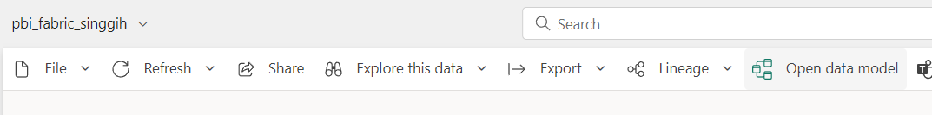
6. Rearrange the tables like the image below to make it easier to view the relationship that will be created later.  
   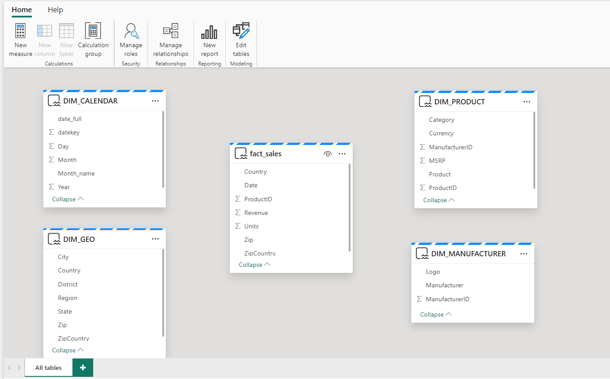
7. Create relationship by dragging foreign key column to the primary key, for example ZipCountry in fact_sales to DIM_GEO  
   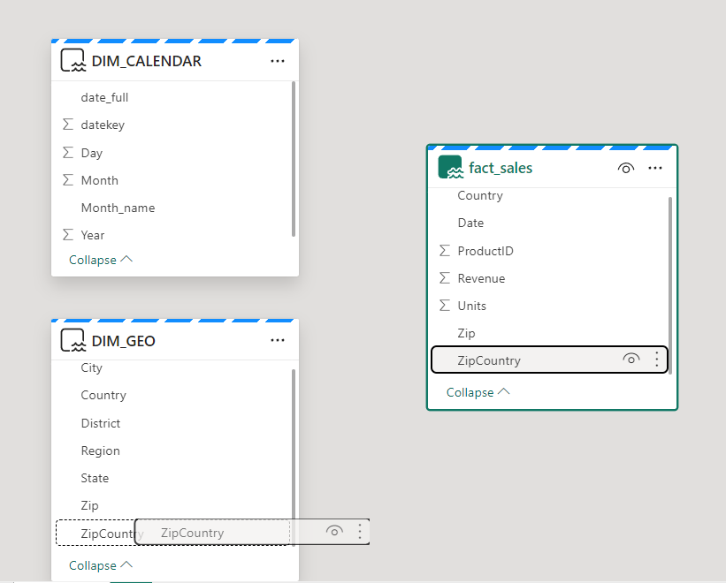
8. Review the **New relationship** dialog :
   * From table : fact_sales with ZipCountry selected
   * To table : DIM_GEO with ZipCountry selected
   * Cardinality : Many to one (*:1)
   * Cross-filter direction : Single
   * Make this relationship active : Selected

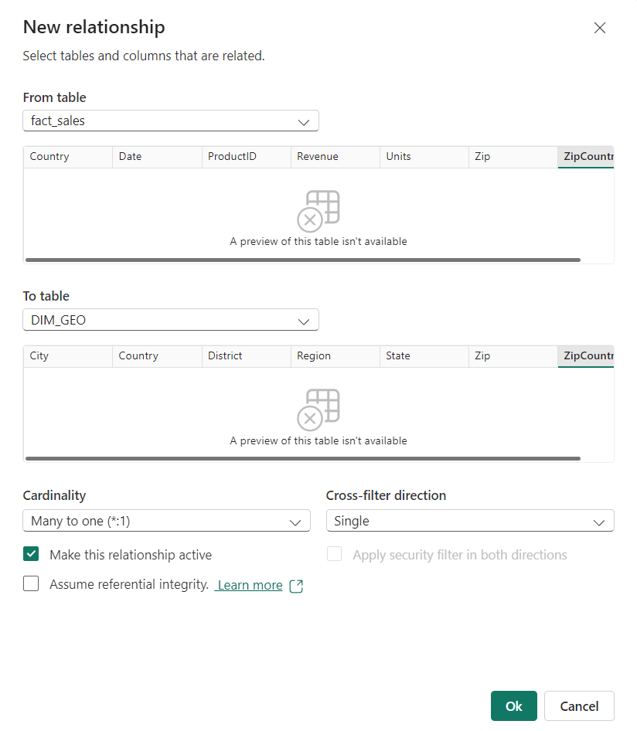

1. Once done click Ok and the relationship can be seen in form of link between both table and an arrow noting the filter direction.  
   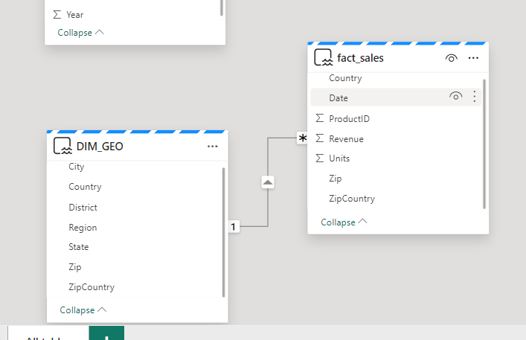
2. Repeat the relationship creation for the other table described below:
   * fact_sales[Date] to DIM_DATE[date_full]  
     **note:** You can change the data type of the column by changing the properties.  
     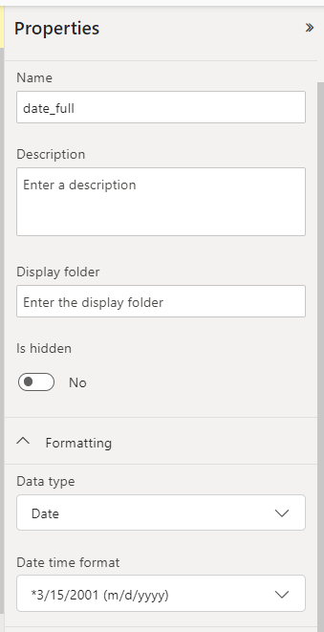
   * fact_sales[ProductID] to DIM_PRODUCT[ProductId]
   * DIM_PRODUCT[ManufacturerId] to DIM_MANUFACTURER[ManufacturerId]
3. Once finished, you will have the data model similar to example below.  
   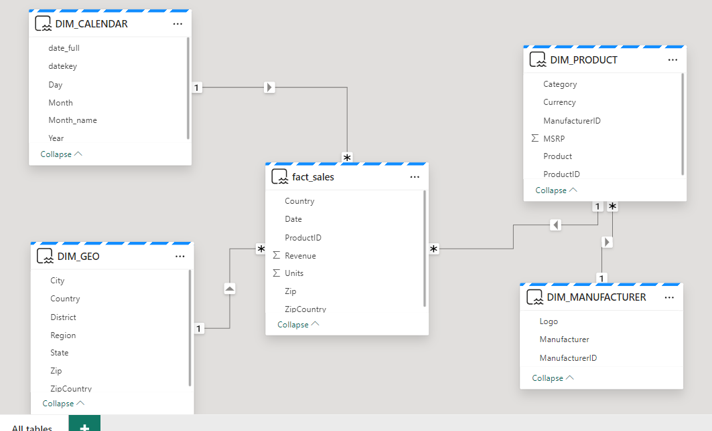
4. Next we will create measures using dax. Select the fact_sales table and click **New measure** button.  
   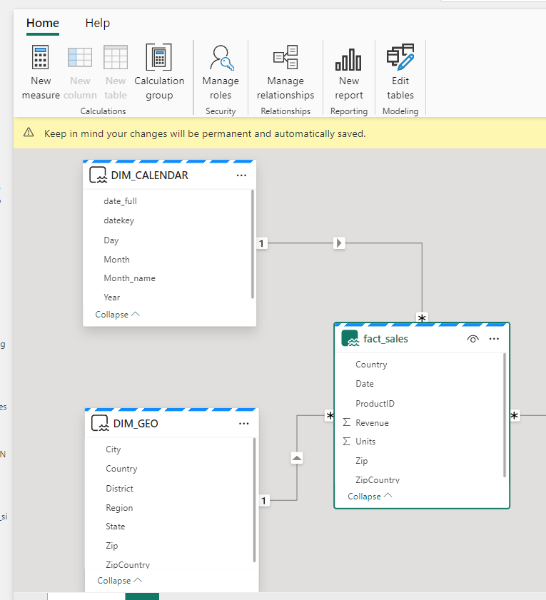
5. Type the following dax formula to the formula bar then click the **Checkmark** button to the left.  
   *Sales Revenue = SUM(fact_sales[Revenue])*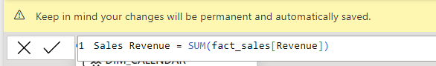
6. Select the created measure from the Data pane to the right, on the Properties pane change the data type to Decimal number, enable the Thousand separator and set Decimal places to 2.  
   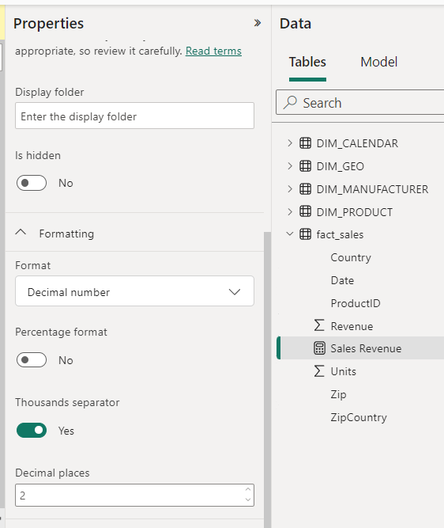
7. Create another measure on fact_sales with formula  
   *Sales Qty = SUM(fact_sales[Units])*Change the result measure data type to Whole number (if not already).
8. Next, we will create calculation group to group similar calculations. Click **Calculation group** button, change the **Calculation item** to Total in the formula bar.  
   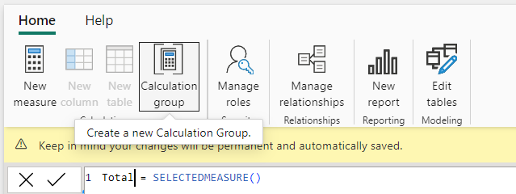
9. Double click on the Calculation group and rename it to Averages
10. Double click on the Calculation group column and rename it to Averages  
    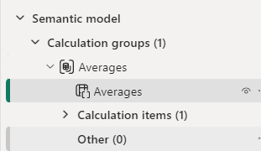
11. Next, add new calculation items by right clicking the Calculation items:  
    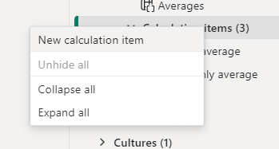
    * *Daily average = AVERAGEX ( VALUES ( DIM_CALENDAR[date_full]), SELECTEDMEASURE())*
    * *Monthly average = AVERAGEX ( VALUES ( DIM_CALENDAR[Month]), SELECTEDMEASURE())*
12. Next change the calculation item order with Total on top and Monthly average last.  
    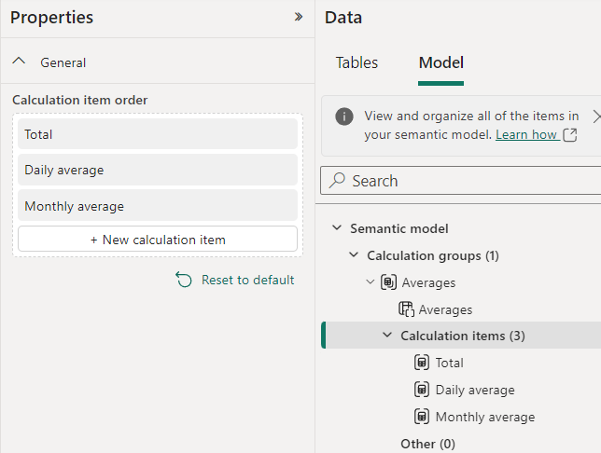
13. Create a new calculation group and name it **Time Intelligence**,also rename the Calculation group column to **Show as**. Add calculation items below and then reorder them as shown:
    * *Current = SELECTEDMEASURE()*
    * *MTD = CALCULATE(SELECTEDMEASURE(),DATESMTD(DIM_CALENDAR[date_full]))*
    * *QTD = CALCULATE(SELECTEDMEASURE(),DATESQTD(DIM_CALENDAR[date_full]))*
    * *YTD = CALCULATE(SELECTEDMEASURE(),DATESYTD(DIM_CALENDAR[date_full]))*
    * *PY = CALCULATE(SELECTEDMEASURE(),SAMEPERIODLASTYEAR(DIM_CALENDAR[date_full]))*
    * *YoY = SELECTEDMEASURE() - CALCULATE (SELECTEDMEASURE(), 'Time Intelligence'[Show as] = "PY")*
    * *YoY% = DIVIDE (CALCULATE (SELECTEDMEASURE(),'Time Intelligence'[Show as] = "YoY"), CALCULATE (SELECTEDMEASURE(), 'Time Intelligence'[Show as] = "PY"))*

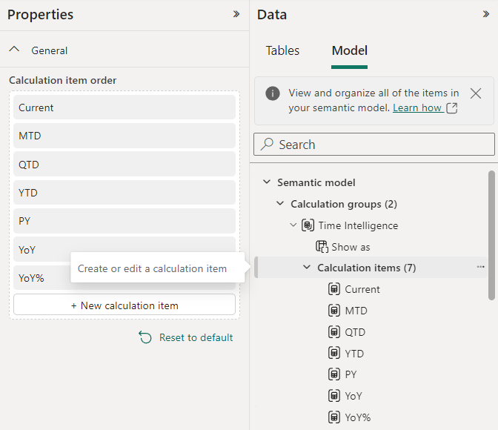

1. Select the calculation item YoY%, on the **Properties** pane enable the Dynamic format string and enter this in the formula bar *"#,##0.00%"* . Then click the checkmark to the left of formula bar.  
   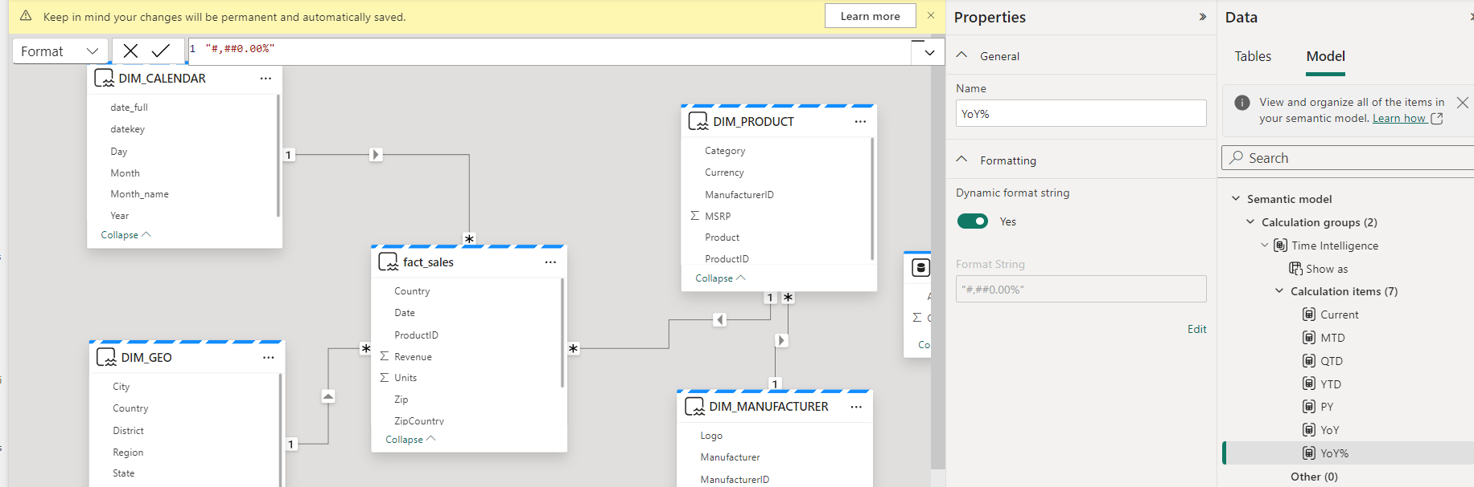
2. Next, we will create visualizations based on the semantic model. Click the New report button to open a new browser tab of power bi.  
   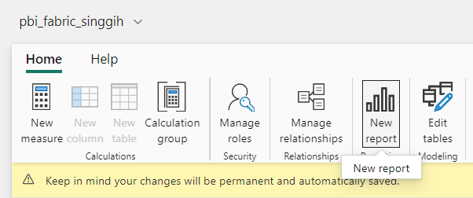
3. On the visualization pane, select matrix visual  
   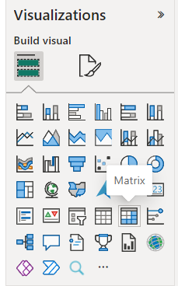
4. Move the created placeholder to the lower part of the canvas and resize it to fill half the page.  
   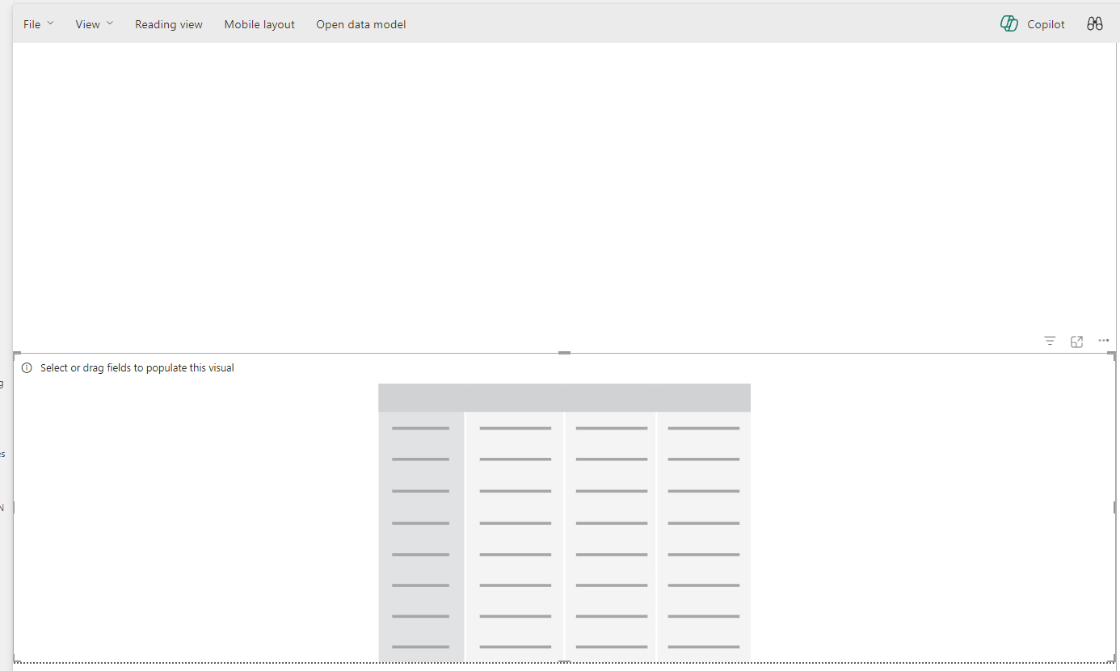
5. Drag data from the Data pane to the slot in visualizations pane following this example to make a simple matrix visual.  
   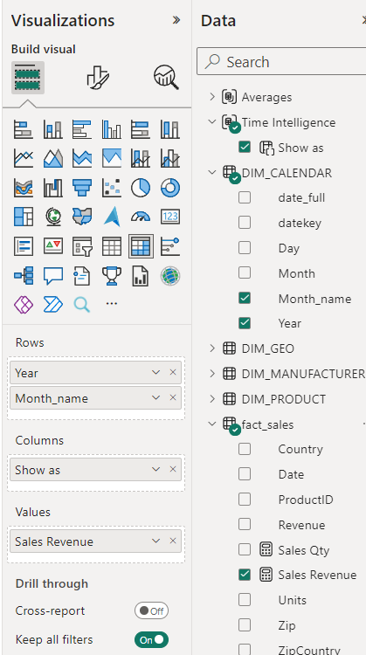
6. Once finished a matrix visual will be created on the canvas that looks like this  
   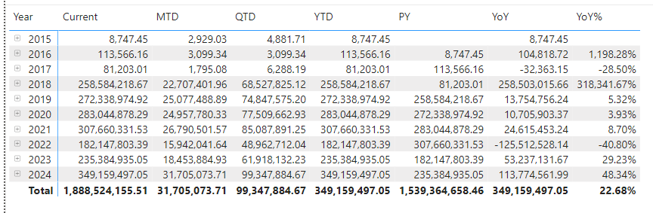
7. Notice that the value for year 2015-2017 is too small, we will now keep them from being shown on visuals.
8. On the Filter pane, drag Year column from DIM_CALENDAR and set the filter to only show data when year is greater than 2018 then click Apply filter.  
   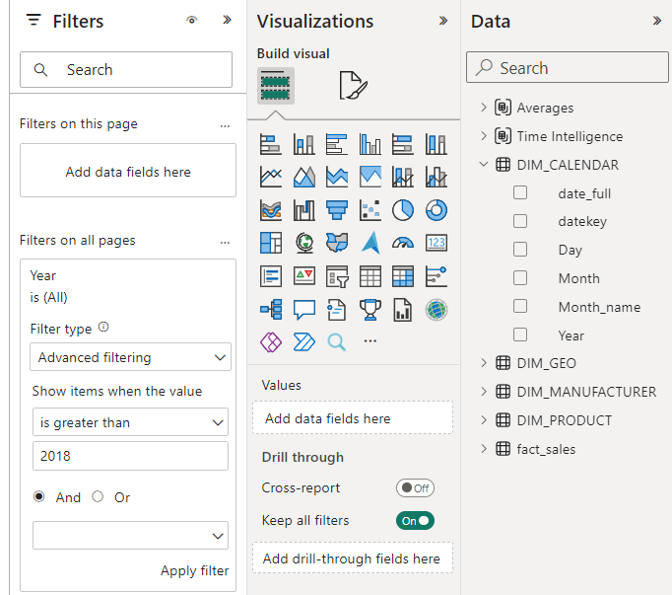
9. Once filtered the matrix will change and only show data from 2019 and above.  
   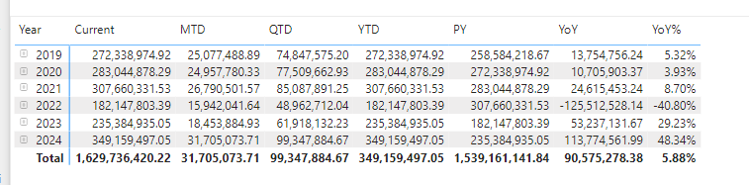
10. Next is adding slicer to the canvas. On Visualization pane, click the slicer visual to add it to the canvas. Then drag Manufacturer from DIM_MANUFACTURER to the field properties.  
    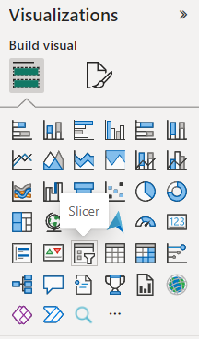
11. Next is changing the visual format, choose **Format visuals** on Visualization pane. On the Slicer settings > Options > Style, change it to Tile. Also check the Filters pane, change the Filters on this visual section. Set it to display all values except (Blank).  
    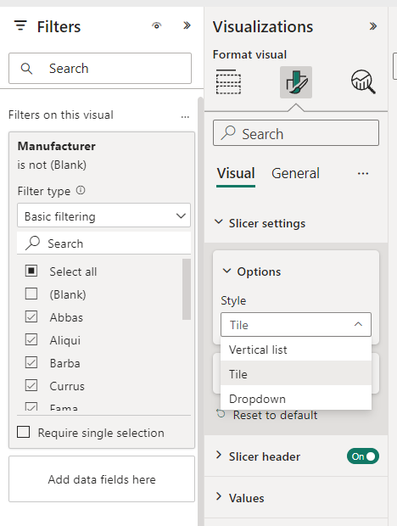
12. Resize the visual on the canvas until it shows 2 rows of tiles.  
    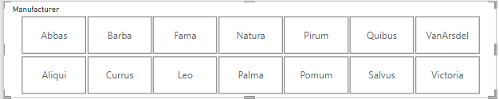
13. Next, we will add a title using shapes, on the top right of toolbar. Click Shapes and choose Rectangle.  
    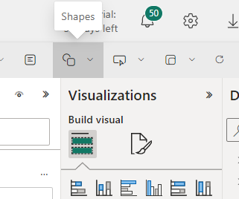
14. Change the shape format as you like it, Assign the title text in Style>Text.  
    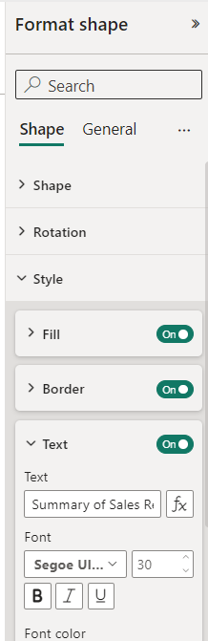
15. Reposition and resize it to make it appear on the top part of the canvas.  
    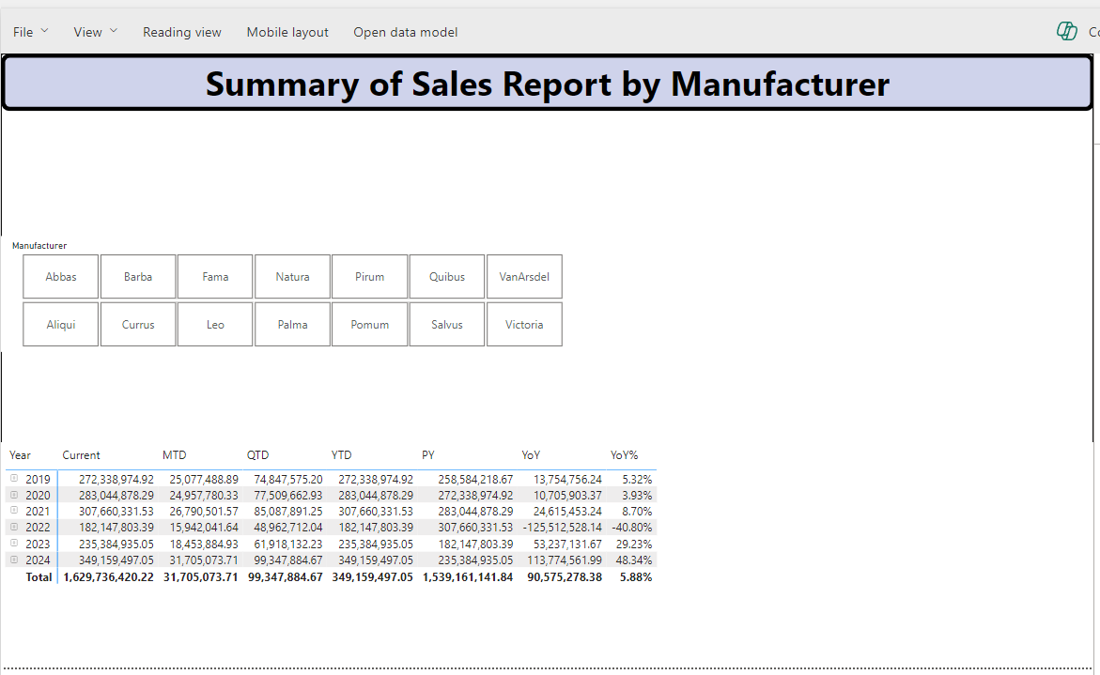
16. Next add a date slicer using date_full column. Notice that the resulting slicer has a slider for date range selection. This happened because the data type of column is date/datetime.  
    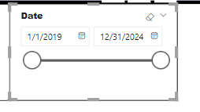
17. Create a new visual of type Stacked bar chart. Use Country from DIM_GEO for Y-axis, Sales Qty for X-axis, and Category from DIM_PRODUCT as Legend.  
    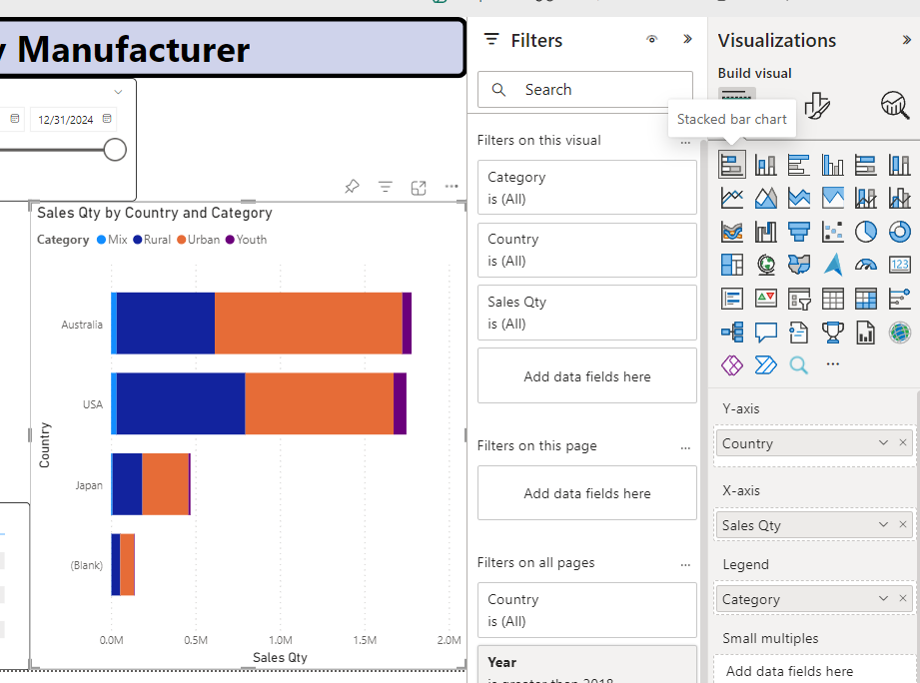
18. Notice the (Blank) country data, it seems we have data that needs to be cleansed. For now, we can add Filter on all pages where **Country** is not (Blank).  
    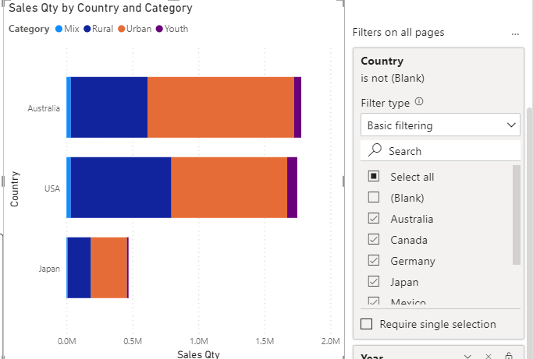
19. Try selecting a single row in the matrix, you will see the stacked bar chart got highlighted on a part of the bar.  
    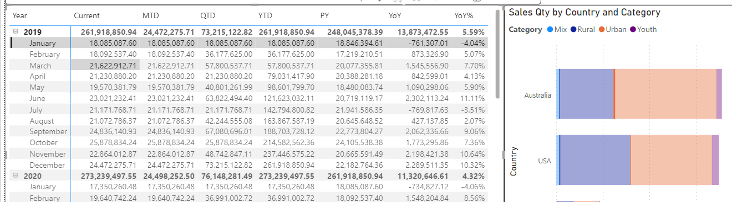
20. This is called intractions between visuals. To change it, enable Edit Interactions mode  
    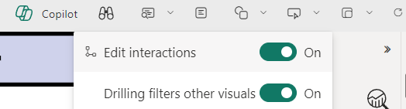
21. Select the matrix and the icon for interations will show on top/bottom of other visuals.Change the Matrix to Filter interaction.   
    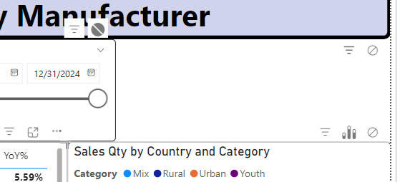
22. Notice the interaction has been changed from highlight to filter.  
    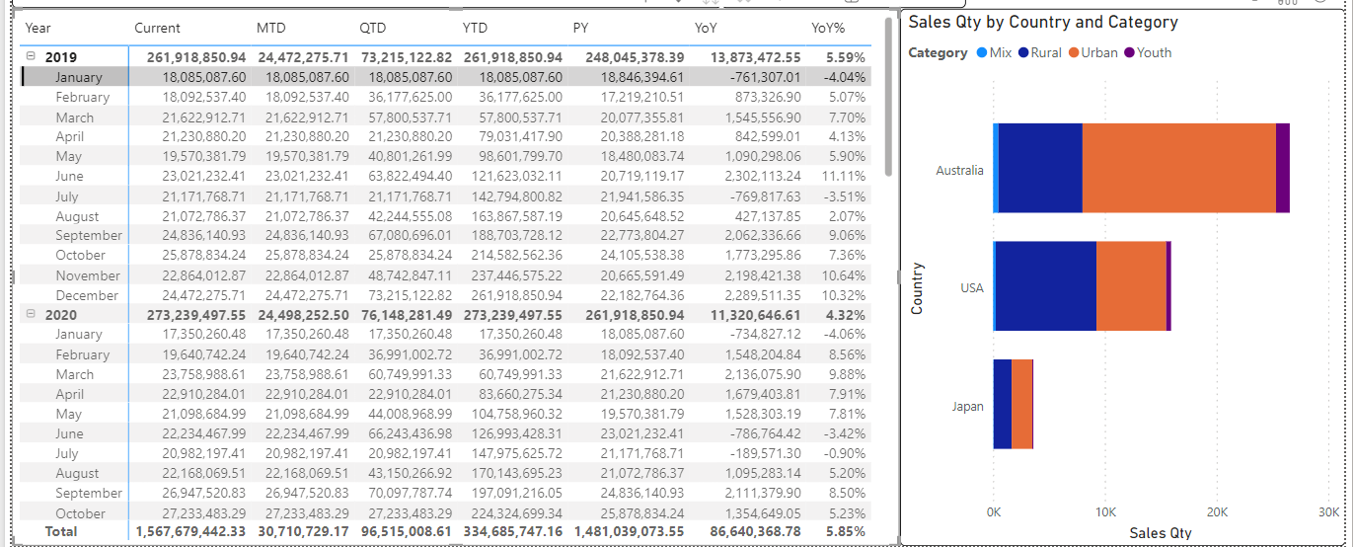
23. Once finished disable the edit interaction and save the report by clicking File > Save/Save as. Save the report as **pbi_report_<your name>.** Once saved, click Reading view to exit editor and see the report as a viewer.  
    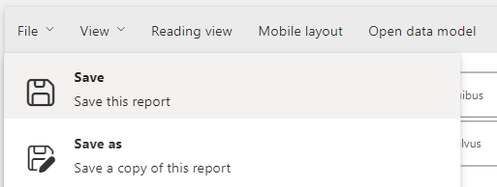
24. You can always go back to edit your report by using the Edit button.  
    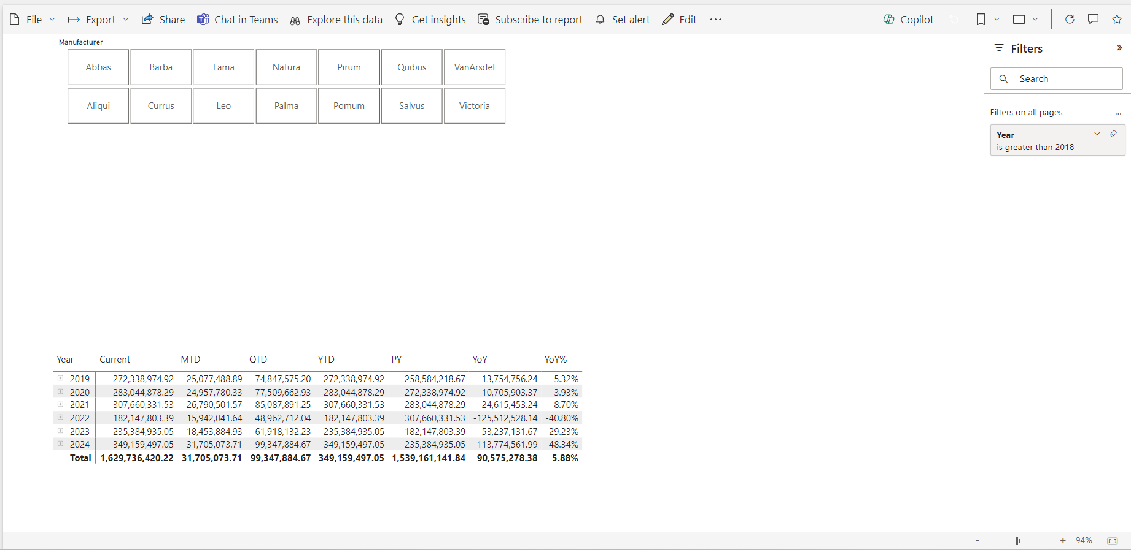

# Clean Up Resources

After you are finished in exploring fabric capabilities, you can delete the workspace by going into workspace settings, go to Others tab and click the Remove this workspace button.

